**Cloud Removal in Satellite Images:  
An Image Processing Approach**

*By*

Rishika Agrawal (Btech/10508/21)

Honey Pradhan (Btech/10168/21)

Shreya Gupta (Btech/10429/21)



Electronics and Communication Engineering

# Birla Institute of Technology, Mesra Ranchi, Jharkhand-835215

### APPROVAL OF THE MENTOR

Recommended that the B. Tech. Minor Project entitled **Cloud Removal in Satellite Images: An Image Processing Approach** submitted by **Rishika Agrawal (BTECH/10508/21), Shreya Gupta (BTECH/10429/21) and Honey Pradhan (BTECH/10168/21) +**

is approved by me for submission. This should be accepted as fulfilling the partial requirements for the award of Degree of Bachelor of Technology in **Electronics and Communication Engineering**. To the best of my knowledge, the content of this report does not form a basis for the award of any previous degree to anyone else.

**Date: Dr. Prajna Parimita Dash**

**Assistant Professor**

**Department of Electronics & Communication Engineering**

**Birla Institute of Technology, Mesra**

### DECLARATION CERTIFICATE

I certify that,

1. The work contained in the report is original and has been done by myself under the general supervision of my supervisor.
2. The work has not been submitted to any other Institute for any other degree or diploma.
3. I have followed the guidelines provided by the Institute in writing the report.
4. I have conformed to the norms and guidelines given in the Ethical Code of Conduct of the Institute.
5. Whenever I have used materials (data, theoretical analysis, and text) from other sources, I have given due credit to them by citing them in the text of the report and giving their details in the references.
6. Whenever I have quoted written materials from other sources, I have put them under quotation marks and given due credit to the sources by citing them and giving required details in the references.

**Date: Rishika Agrawal, Honey Pradhan, Shreya Gupta**

**BTECH/10508/21, BTECH/10168/21, BTECH/10429/21**

**Department of Electronics & Communication Engineering**

**Birla Institute of Technology, Mesra**

### CERTIFICATE OF APPROVAL

This is to certify that the work embodied in this Summer Internship Report entitled:

“**Cloud Removal in Satellite Images: An Image Porcessing Approach** ”,

is carried out by Rishika Agrawal (BTECH/10508/21), Shreya Gupta (BTECH/10429/21) and Honey Pradhan (BTECH/10168/21)has been approved for the degree of Bachelor of Technology in Electronics and Communication Engineering of Birla Institute of Technology, Mesra, Ranchi.

Date:

Place:

(Chairman) (Panel Coordinator)

Head of the Department Examiner

Dept. of ECE Dept. of ECE

#### ABSTRACT

Satellite-borne optical imagery is challenged by the pervasive and unavoidable issue of clouds. To effectively utilize remote sensing data, accurate, well-documented, and automated cloud detection algorithms are required. The Landsat project is an ideal platform for comparative validation of cloud detection algorithms due to its modular architecture and comprehensive manual truth masks. At present, the Landsat Level-1 Product Generation System (LPGS) utilizes separate algorithms for clouds, cirrus clouds, and snow and/or ice probability on a per-pixel basis. However, the US Geological Survey (USGS) is developing a more robust algorithm that can work across multiple Landsat sensors with minimal modification. This algorithm can operate with and without thermal data, which is necessary to account for the inherent error from stray light and intermittent data availability of TIRS.

The methodology begins with systematic data collection from platforms like EarthExplorer, laying the groundwork for subsequent processing. Advanced algorithms like CFMask are then employed to accurately identify and classify cloud pixels, crucial for distinguishing clouds from other surface features. The efficacy of our methodology is validated through rigorous testing, demonstrating significant improvements in image clarity and utility. By eliminating clouds and restoring obscured regions, our approach empowers researchers, analysts, and decision-makers to extract clearer insights from satellite imagery.

Among the algorithms researched, CFMask, a C code based on the Function of Mask (Fmask) algorithm, and its confidence bands, had the best overall accuracy. Thus, the researchers recommend the use of CFMask for operational cloud and cloud shadow detection because it is derived from physical phenomena and is operable without geographic restriction. This makes it useful for current and future land imaging missions without the need for retraining in a machine-learning-environment.

#### ACKNOWLEDGEMENT

We would like to take this opportunity to express our sincere gratitude to those who have supported us throughout our project on cloud removal from satellite images.

First and foremost, we would like to extend our deepest appreciation to our guide, Dr. Prajna Parimita Dash, for her invaluable mentorship and guidance. Her extensive knowledge and unwavering support have been instrumental in shaping our research and helping us achieve our objectives. We would also like to express our gratitude to the Head of the Department of Electronics and Communication Engineering (ECE) and the committee members for their support and valuable insights. Their constructive feedback and encouragement have been invaluable in helping us refine our research and improve its quality.

Furthermore, we would like to extend special appreciation to Dr. Neerav Sharma Sir for his invaluable assistance at every step of the project. His expertise and guidance have been crucial in helping us overcome various challenges and achieve our goals.

Lastly, we would like to thank our friends for their constant encouragement and support throughout our project. Their unwavering belief in our abilities has been a source of motivation for us, and we are grateful for their unwavering support.

Date: (Signature)

Honey Pradhan, Rishika Agrawal & Shreya Gupta

BTECH/10168/21, BTECH/10508/21 & BTECH/10429/21

#### CONTENTS

**ABSTRACT v**

**ACKNOWLEDGEMENT vi**

**LIST OF FIGURES ix**

**LIST OF TABLES x**

**CHAPTER 1 INTRODUCTION 1**

* 1. **Satellite Imaging 1**
  2. **Applications of Satellite Imaging 2**
  3. **Characteristics of Satellite Imaging 4**
  4. **Different Types of Satellites in Use Today 5**
  5. **Types of Clouds 7**
  6. **Motivation 8**
  7. **Objectives 9**
  8. **Challenges in Cloud Removal 9**
  9. **Interpolation………………………………………………………………………………..11**
  10. **Inverse Distance Weighting (IDW) ……………………………………………………....13**
  11. **Fractal Interpolation………………………………………………………………………15**

**CHAPTER 2 LITERATURE REVIEW 18**

**CHAPTER 3 METHODOLOGY 20**

**3.1. Dataset Collection 21**

**3.2. Generating RGB Cloudy Image 22**

**3.3. Cloud Masking 23**

**3.3.1. CF Mask 24**

**3.3.2. Bit Plane Slicing 25**

**3.4. Removing Clouds 26**

**3.5. Inpainting 26**

**3.5.1. Area of Interest 27**

**3.5.2. Entire Image 28**

**CHAPTER 4 RESULTS AND DISCUSSION 29**

**CHAPTER 5 CONCLUSION AND FUTURE SCOPE 34**

**REFERENCES 36**

#### LIST OF FIGURES

|  |  |  |
| --- | --- | --- |
| Figure 1.1 | Examples of practical remote sensing technology to the Earth’s Surface | 2 |
| Figure 1.2 | Applications of Satellite Imaging | 3 |
| Figure 1.3 | Motivation for Cloud Removal | 9 |
| Figure 1.4 | Interpolation | 11 |
| Figure 1.5 | Inverse Distance Weighting (IDW) | 14 |
| Figure 3.1 | Work Flow for the Proposed Method | 20 |
| Figure 3.2 | RGB Cloudy Image | 23 |
| Figure 3.3 | Landsat segmentation mask with 4 cover types - cloud, shadow, dilated cloud and cirrus of (a) Complete Landsat image (b) Cropped Area of interest | 26 |
| Figure 3.4 | (a) Cloudy Area Of Interest (b) Generated Inpainted Image of Area Of Interest | 27 |
| Figure 4.1 | (a) Original Cloudy Image (b) Generated Inpainted Image of Area of Interest | 29 |
| Figure 4.2 | (a) Original Cloudy Image (b) Generated Inpainted Image of Area of Interest | 30 |
| Figure 4.3 | (a) Original Cloudy Image (b) Generated Interpolated Image using IDW | 31 |
| Figure 4.4 | (a) Original Cloudy Image (b) Generated Interpolated Image using Fractal Interpolation | 33 |
|  |  |  |
|  |  |  |
|  |  |  |
|  |  |  |
|  |  |  |

#### 

#### LIST OF TABLES

|  |  |  |
| --- | --- | --- |
| Table 1.1 | The primary spectral regions used in Earth remote sensing | 6 |
| Table 1.2 | Types of Clouds | 7 |
| Table 2.1 | Literature Survey | 12 |
| Table 3.1 | Landsat 8 and Landsat 9 Pixel QA_PIXEL Value Interpretations | 14 |
| Table 3.2 | Landsat Orbit Properties | 15 |
| Table 3.3 | Cloud Characterization using Bit Plane Slicing | 18 |

***CHAPTER 1***

### INTRODUCTION

### 1.1 SATELLITE IMAGING

Traditionally, understanding Earth's vast and intricate landscapes relied on ground-based observations or aerial photography. However, the advent of remote sensing satellite imaging has revolutionized our ability to study our planet. Remote sensing is an advanced technology used to measure the reflected and emitted radiation of a particular area from a distance, typically using satellites or aircraft. By analyzing this data, scientists can gain valuable insights into the physical characteristics of the area being studied, which can help us better understand and manage our planet's resources. This technology utilizes a network of sophisticated satellites equipped with advanced sensors orbiting Earth, capturing not just visible light but a wider electromagnetic spectrum. This allows us to "see" beyond what the human eye perceives, revealing valuable information about the planet's surface, atmosphere, and even oceans.

Cloud obstruction is a significant obstacle in the field of satellite imaging. Cloud cover can obscure the Earth's surface, limiting the effectiveness of satellite observations, particularly in regions prone to frequent cloud cover or during certain seasons. Researchers and engineers continue to develop innovative techniques to mitigate the impact of clouds, ranging from cloud detection algorithms to advanced image processing methods that remove or minimize cloud interference.

To effectively use remote sensing data, it is crucial to have accurate, and automated cloud detection algorithms in place. Landsat project is a useful platform for developing and testing these algorithms due to its modular architecture and comprehensive manual truth masks, which provide a reliable way to compare different cloud detection approaches. The Landsat L1 Product Generation System (LPGS) relies on the separate algorithms for detecting clouds, and snow or ice probability on per-pixel basis.

In addition to cloud obstruction, atmospheric distortions pose significant challenges in satellite imaging. Factors such as haze, aerosols, and scattering can degrade image quality and introduce inaccuracies into the data. These atmospheric effects vary spatially and temporally, making it challenging to correct for their influence on satellite imagery. Advanced atmospheric correction algorithms and atmospheric models are employed to account for these distortions and enhance the accuracy of satellite-derived products. By addressing these challenges through the development of innovative techniques, remote sensing data can provide more accurate and comprehensive insights into environmental conditions and changes.

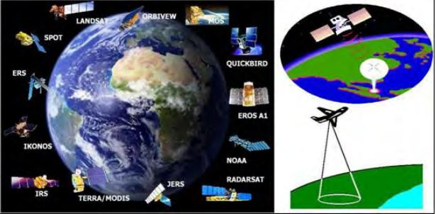

Figure 1.1 Examples of practical remote sensing technology to the Earth’s Surface

**1.2 APPLICATIONS OF SATELLITE IMAGING**

The applications of satellite imaging are vast and varied, and have had a profound impact on how we observe, comprehend, and interact with our planet. Some of the key areas where satellite imaging has been instrumental include:

**1. Environmental Monitoring:** By enabling the tracking of deforestation, urban expansion, changes in water bodies, and land degradation on a global scale, satellite imagery has become an indispensable tool in monitoring environmental changes. This information helps policymakers and scientists to better understand the dynamics of ecosystems and assess the impact of human activities on the environment.

**2. Natural Resource Management:** Satellite imaging plays a vital role in managing natural resources such as forests, agricultural lands, and water resources. It provides valuable data for assessing land cover and land use changes, monitoring crop health and productivity, and managing water availability and quality. The use of satellite-based monitoring helps optimize resource allocation, improve agricultural practices, and support sustainable land management strategies.

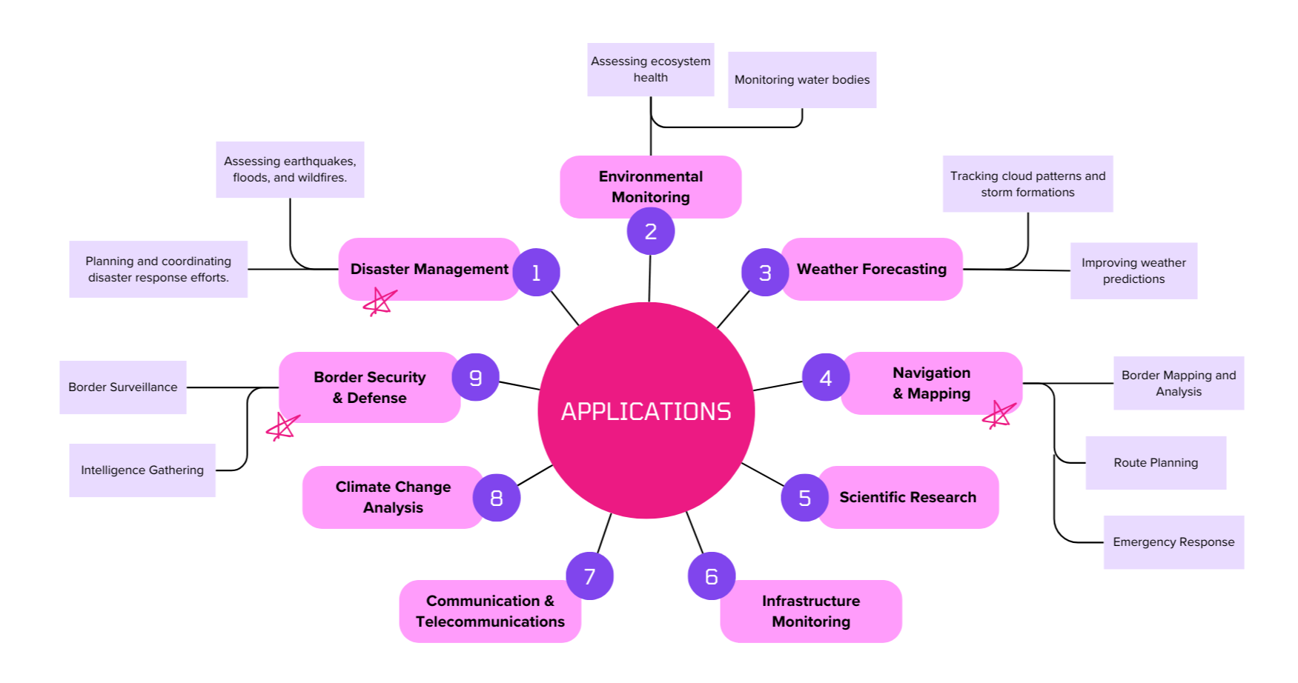

Figure 1.2 Applications of Satellite Imaging

**3. Disaster Management and Response:** Satellite imagery plays a crucial role in disaster management and response efforts. It enables rapid assessment of the extent and severity of natural disasters such as hurricanes, floods, wildfires, and earthquakes. Satellite images help identify affected areas, assess damage, and prioritize response actions, facilitating timely and effective disaster relief efforts.

**4. Climate Change Studies:** Satellite imaging provides long-term observational data on key climate variables such as temperature, precipitation, sea ice extent, and greenhouse gas concentrations. This data helps researchers track changes in Earth's climate system, identify trends and patterns, and improve climate models for predicting future climate scenarios. This information is essential for assessing the impact of climate change on ecosystems, biodiversity, and human societies.

**5. Urban Planning and Infrastructure Development:** Satellite imagery provides valuable information on urban growth, land use patterns, transportation networks, and infrastructure assets. This information helps cities optimize land use, plan transportation routes, and monitor urban expansion to support sustainable urban development.

**6. Military Surveillance:** Satellite imagery is extensively used for monitoring military activities, assessing potential threats, and tracking troop movements. It provides valuable intelligence to military agencies for strategic planning, threat assessment, and situational awareness. Satellite images are analyzed to identify military installations, evaluate enemy capabilities, and detect suspicious activities in conflict zones.

**1.3 CHARACTERISTICS OF SATELLITE IMAGING**

Satellite images possess a number of discernible characteristics that impact their quality, utility, and applicability across various domains. Some of the key characteristics of satellite images include:

**1. Spatial Resolution:** Among the key characteristics of satellite images, spatial resolution is defined as the level of detail or ground area coverage captured by a single pixel in the image. It is determined by the size of the sensor's pixel and can affect the ability to distinguish objects and features on the Earth's surface. High spatial resolution images provide finer detail, but cover smaller areas, while low spatial resolution images cover larger areas with less detail.

**2. Spectral Resolution:** Spectral resolution refers to the number and width of spectral bands or channels captured by the sensor. Different bands represent different portions of the electromagnetic spectrum, such as visible, near-infrared, and thermal infrared. Higher spectral resolution enables better discrimination between different surface materials and properties, thereby allowing for advanced analysis techniques such as land cover classification and vegetation health assessment.

**3. Temporal Resolution:** Temporal resolution is defined as the frequency with which the satellite revisits the same location on the Earth's surface. It is determined by the satellite's orbital characteristics and imaging schedule. Higher temporal resolution provides more frequent updates and allows for monitoring of dynamic processes such as vegetation growth, land use changes, and natural disasters in near real-time.

**4. Radiometric Resolution:** Radiometric resolution, on the other hand, refers to the sensor's sensitivity to variations in brightness or intensity within each spectral band. It determines the number of distinct brightness levels or grey levels that can be represented in the image. Higher radiometric resolution allows for better differentiation of subtle variations in surface reflectance or temperature, thereby improving the accuracy of quantitative analysis tasks such as change detection and classification.

**5. Geometric Accuracy:** Geometric accuracy refers to the accuracy with which the spatial location and shape of features on the Earth's surface are represented in the image. It is influenced by factors such as sensor calibration, orbital parameters, and terrain variations. High geometric accuracy is essential for precise mapping, geospatial analysis, and integration with other geospatial datasets.

In conclusion, each of these characteristics plays a pivotal role in the satellite image's application and analysis, ranging from vegetation health assessment to precise mapping and geospatial analysis. Understanding these characteristics and their interactions is essential for utilizing satellite imagery effectively in various domains.

**1.4 Different Types of Satellites in Use Today**

Each type of satellite serves specific purposes and provides unique capabilities for monitoring and understanding the Earth's environment, atmosphere, and space. Together, they form a comprehensive network of satellites that support a wide range of scientific, commercial, and governmental applications.

They are mentioned as under:

1. **Landsat 8 & 9:**

Landsat satellites, which are operated by NASA and the USGS, serve as Earth observation satellites equipped with sensors that capture imagery in multiple spectral bands, including visible, near-infrared, and thermal infrared. These satellites are capable of providing global coverage of the Earth's land surface with a spatial resolution of 30 meters for most bands. Landsat satellites are extensively employed for several applications, including land cover mapping, agricultural monitoring, forest management, and environmental change detection.

Table 1.1 The primary spectral regions used in Earth remote sensing

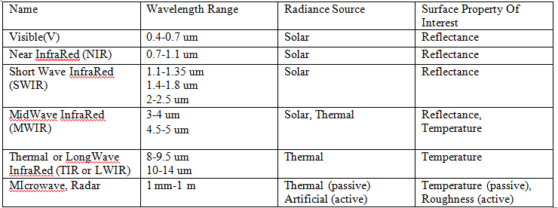

**2. Sentinel-2:**

The Sentinel-2 satellites are a component of the European Union's Copernicus program aimed at Earth observation. These satellites are equipped with multispectral imagers that capture high-resolution imagery in 13 spectral bands, including visible, NIR, and short-wave infrared. The Sentinel-2 satellites offer global coverage of Earth's land surface with spatial resolution of 10-20 meters. They are utilized for various applications, including land cover mapping, agricultural monitoring, disaster management, and urban planning.

**3. GOES (Geostationary Operational Environmental Satellite) Series:**

The GOES (Geostationary Operational Environmental Satellite) satellites, operated by the National Oceanic and Atmospheric Administration (NOAA), are utilized for weather monitoring and forecasting. These satellites are placed in geostationary orbits, providing uninterrupted monitoring of weather patterns and atmospheric conditions over specific regions, such as North America. The GOES satellites are equipped with instruments that capture imagery in visible, infrared, and water vapor channels, enabling the monitoring of clouds, storms, and other weather phenomena.

**4. MODIS (Moderate Resolution Imaging Spectro-radiometer):**

NASA's Terra and Aqua satellites carry MODIS (Moderate Resolution Imaging Spectroradiometer) instruments that capture imagery in various spectral bands, including visible, near-infrared, and thermal infrared, at moderate spatial resolutions. These instruments provide global coverage of the Earth's surface with a spatial resolution ranging from 250 meters to 1 kilometer. MODIS instruments have numerous applications, such as monitoring land surface temperature, assessing vegetation health, detecting wildfires, and conducting atmospheric studies.

In contrast, the Landsat Satellites have visible and near-infrared (VNIR) bands and thermal infrared (TIR) bands, while the Sentinel-2 satellite has a multispectral instrument (MSI) capable of acquiring both VNIR and shortwave-infrared (SWIR) data.

**1.5 TYPES OF CLOUDS**

**1. Thin Clouds:**

* **Cirrus Clouds:** Located at high altitudes made up of ice crystals having wispy, feathery appearance.
* **Cirrostratus Clouds:** Thin, high-altitude clouds that cover the sky like a veil.
* **Cirrocumulus Clouds:** High-altitude clouds appearing as small, white patches or ripples.

Table 1.2 Types of Clouds

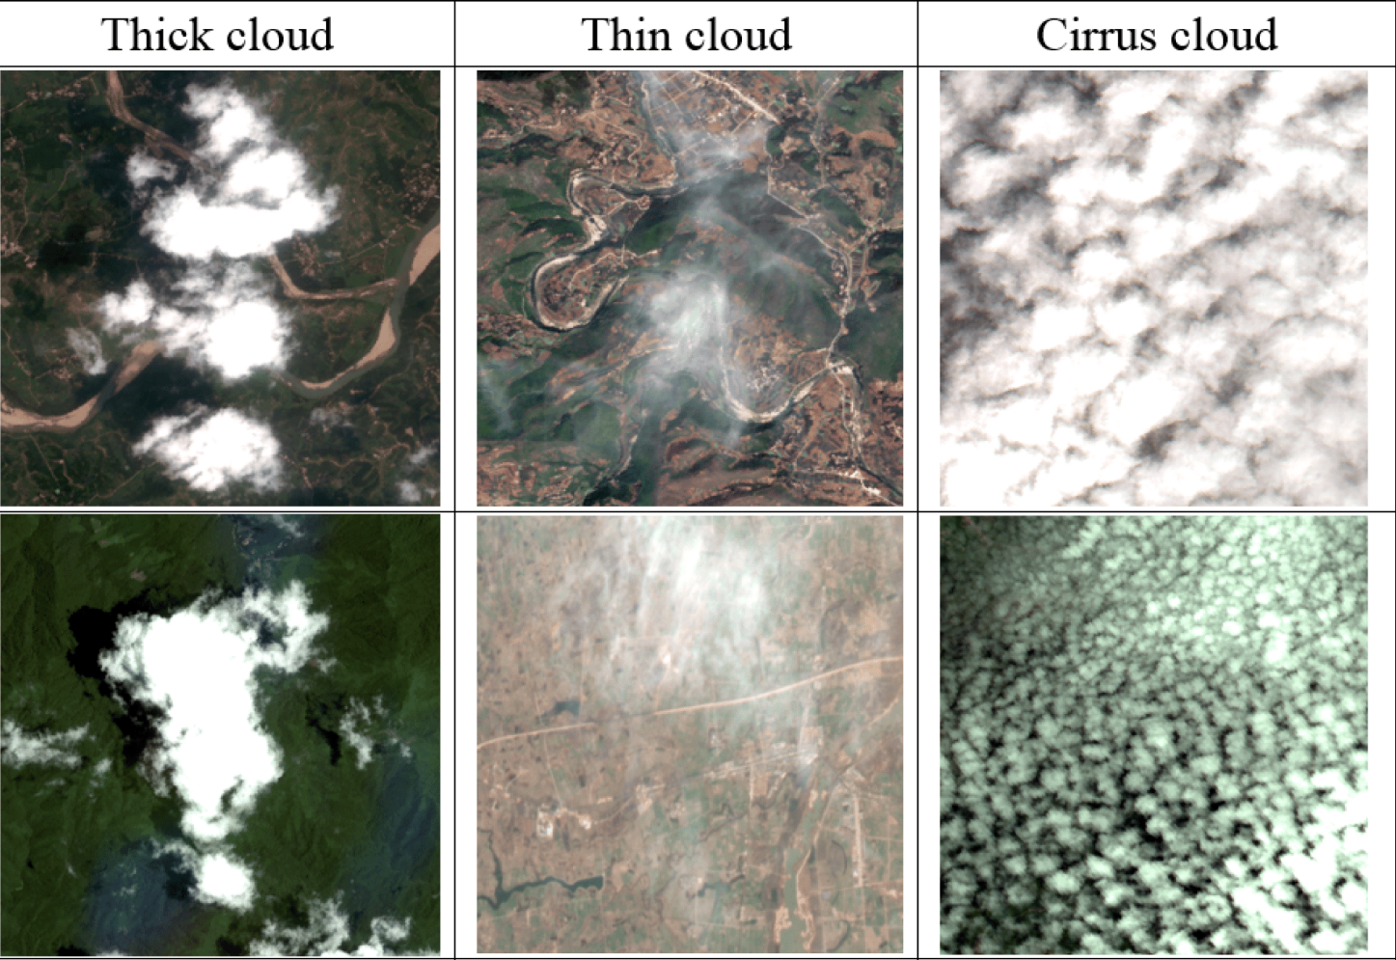

|  |  |  |
| --- | --- | --- |
| 10,000 - 20,000 ft  Above ground | 262,000 - 279,000 ft  Above ground | 15,000 - 30,000 ft  Above ground |
| observed using bands within shortwave infrared (SWIR) | observed using bands within shortwave infrared (SWIR) or near-infrared (NIR) | observed using bands within visible or near-infrared (NIR) |
| Contains larger concentrations of water droplets & ice crystals. | Appears wispy,  with delicate, filamentous structure. | Banded fibrous structure.  Underlying terrain & lower clouds often visible. |

**2. Thick Clouds:**

* **Cumulonimbus Clouds**: Towering clouds associated with thunderstorms, heavy rain, and severe weather.
* **Stratocumulus Clouds:** Low- to mid-level clouds forming in a patchy layer, sometimes dense enough to block sunlight.
* **Altostratus Clouds**: Mid-level clouds that often cover the sky in a greyish layer, blocking sunlight but not as dense as nimbostratus clouds.
* **Cumulus Clouds:** Puffy, white clouds with flat bases, varying in thickness depending on development.

**1.6 MOTIVATION**

* While clouds are a natural and integral part of the Earth's atmosphere, their presence in satellite imagery often obscures valuable information about the Earth's surface and hampers the effectiveness of data analysis.
* They can obstruct the view of the Earth's surface, causing shadows, reflections, and distortions in satellite images. Moreover, clouds can change rapidly over time, leading to temporal inconsistencies and variations in image quality. As a result, cloud cover often reduces the temporal resolution of satellite imagery, limiting the frequency and continuity of observations over specific regions and time periods.
* Reduction in temporal resolution, caused by cloud cover, can have significant implications for various applications that rely on timely and up-to-date Earth observation data.Cloud-free imagery enables farmers and agronomists to track changes in crop conditions, identify areas of stress or disease, and implement timely interventions to optimize agricultural practices and maximize yields.
* Therefore, the development of robust cloud removal techniques is essential to enhance the utility and reliability of satellite imagery for a wide range of applications, including monitoring environment, disaster management, agriculture, scientific research, and urban planning.

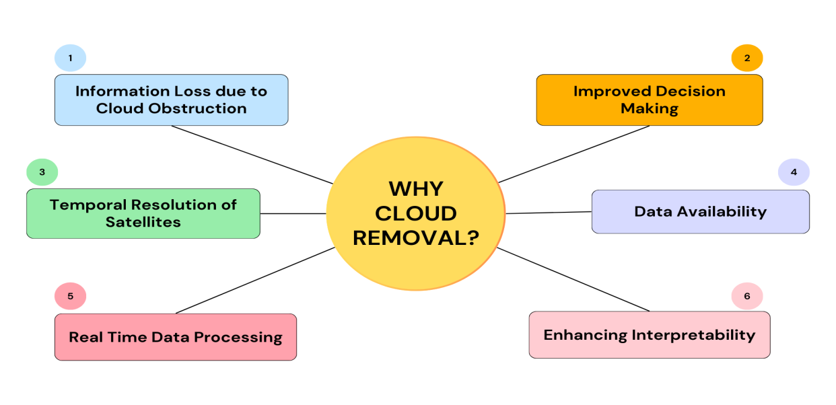

Figure 1.3 Motivation for Cloud Removal

**1.7 OBJECTIVES**

Our objective is to remove cloud obstruction from satellite imagery to provide more accurate and comprehensive insights into environmental conditions and changes. By developing a reliable image processing model that can easily de-cloud the satellite images, we aim to provide high-quality images for analysis and interpretation. This will enable better decision-making, planning, and management of resources for various applications such as environmental monitoring, disaster response, and urban planning.

**1.8 CHALLENGES IN CLOUD REMOVAL**

Cloud masks are an essential tool for satellite imagery analysis, but their accuracy can be limited due to various factors. For example, clouds cannot be replaced with 100% accuracy, and there may be discontinuities in the landscape due to factors such as changes in rivers or tides. Additionally, variations in brightness can cause discontinuities in the landscape. The unavailability of a large number of satellite images of the same location for inpainting was a major issue. The following are some of the challenges that need to be addressed in cloud removal from satellite images:

**1. Complexity of Cloud Patterns:** Clouds come in various shapes, sizes, and densities, making them difficult to identify and remove accurately. Complex cloud patterns, such as overlapping clouds or thin clouds, can further complicate the removal process.

**2. Dynamic Nature of Cloud Cover:** Cloud cover is dynamic and constantly changing, requiring algorithms to adapt in real-time to accurately detect and remove clouds. This dynamic nature poses challenges for cloud removal algorithms, particularly in regions with frequent cloud cover or rapidly changing weather conditions.

**3. Mixed Pixel Problem:** Satellite images often contain mixed pixels, where a single pixel may contain both cloud and non-cloud elements. Resolving this mixed pixel problem accurately is crucial for reliable cloud removal without distorting underlying surface features.

**4. Shadow and Reflection Effects:** Cloud shadows and reflections can mimic cloud cover in satellite images, leading to misclassification and errors in cloud removal. Distinguishing between actual clouds and shadow/reflection artifacts is essential for accurate cloud removal.

**5. Processing Time and Resources:** Cloud removal algorithms can be computationally intensive and require significant processing time and resources, particularly for high-resolution satellite images covering large areas. Efficient algorithms capable of processing large volumes of data in a timely manner are needed to overcome this challenge.

**6. Data Availability and Quality:** The availability and quality of ancillary data, such as atmospheric and topographic information, can significantly impact the accuracy of cloud removal algorithms. Limited availability or inaccuracies in these data sources can hinder the effectiveness of cloud removal techniques.

**7. Validation and Evaluation:** Validating and evaluating the performance of cloud removal algorithms require ground truth data or reference images, which may not always be readily available. Ensuring the reliability and accuracy of cloud removal results through robust validation procedures is essential for assessing algorithm performance.

Addressing these challenges requires a combination of advanced algorithms, robust validation methodologies, and access to high-quality ancillary data. Continued research and development efforts are necessary to improve the accuracy and effectiveness of cloud removal techniques for satellite imagery analysis. With the development of more advanced and reliable cloud removal techniques, satellite imagery analysis can provide more accurate and comprehensive insights into environmental conditions and changes.

**1.9 INTERPOLATION**

Image interpolation is a mathematical technique utilized to estimate unknown pixel values from existing data points, playing an essential role in digital image processing. It is frequently applied during resizing, remapping, or correcting image distortions. Interpolation strives to approximate a pixel's intensity by considering its neighboring pixel values. Nevertheless, because interpolation is inherently an approximation, it inevitably leads to some degree of quality degradation.

When an image is resized or remapped, the original pixel grid is aligned to a new one, which often does not match perfectly with the original grid. This discrepancy requires estimating pixel values at new positions through the use of interpolation algorithms. Different interpolation methods vary in their approach to this estimation, affecting both the computational expense and the quality of the resulting image.

Interpolation algorithms can be divided into two primary categories: adaptive methods and non-adaptive methods. Adaptive interpolation techniques modify their behavior based on the characteristics of the image, treating distinct edges differently from smooth areas. Conversely, non-adaptive methods apply the same mathematical process uniformly across all pixels, regardless of the image's characteristics. These methods are typically simpler in computation and are widely utilized.

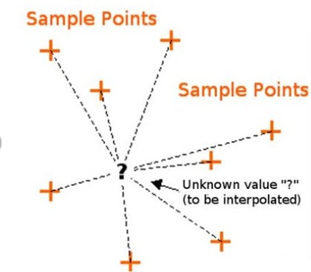

Figure 1.4 Interpolation

The most basic interpolation method, nearest neighbor interpolation, assigns the value of the nearest known pixel to the target pixel. Its low computational demands make it the quickest interpolation method, and it is straightforward to implement. However, this approach leads to images that appear blocky and jagged, especially during enlargement, and it does not provide smooth transitions between pixels, resulting in subpar image quality.

Bilinear interpolation enhances nearest neighbor methods by utilizing the nearest 2x2 grid of pixels (which consists of 4 pixels). It computes a weighted average of these pixels, assigning more weight to those that are closer. This technique yields smoother and more naturally appearing images while maintaining a reasonable computational cost alongside improved quality. Nevertheless, the resulting image may still exhibit a degree of blurriness and may not capture sharp details in areas with high-frequency content.

Bicubic interpolation further improves image quality by taking into account a 4x4 grid of pixels (amounting to 16 pixels) around the target pixel. It employs cubic polynomials to calculate a weighted average, with the weights determined by the distance of each pixel from the target. This technique results in images that are sharper and more detailed compared to the nearest neighbor and bilinear methods, while still managing a balance between high-quality outcomes and computational efficiency. However, it demands more computational resources and is somewhat slower due to the more complex nature of cubic calculations.

Inverse distance weighting (IDW) interpolation determines the value of an unknown pixel by averaging the intensities of surrounding pixels, assigning weights that are inversely related to their distances. Pixels that are closer have a greater influence than those that are farther away. This technique is useful for scenarios where closeness significantly impacts value and offers flexibility, as the weighting function can be adjusted for various applications. Nonetheless, it necessitates the specification of a power parameter for distance weighting, which can affect the outcomes, and may lead to artifacts or unnatural patterns if not set up properly.

Fractal interpolation is a sophisticated technique that employs the concepts of fractals to generate self-similar designs at different scales. This method is especially beneficial for images requiring the retention of fine details, such as textures or patterns. It can yield highly detailed and realistic outcomes while maintaining texture and intricate patterns more effectively than conventional methods. However, it is resource-intensive and complicated to execute, demanding careful adjustment of parameters to achieve natural-looking results.

The selection of interpolation techniques relies on the particular application and its key priorities. Nearest neighbor interpolation is optimal for situations where speed is prioritized over quality, such as generating quick previews. Bilinear interpolation fits well for applications that demand a balance between moderate quality and efficiency. Bicubic interpolation excels in contexts needing high-quality output, like photo editing or medical imaging. IDW interpolation is beneficial for spatial analysis where the closeness of data points significantly affects pixel values, while fractal interpolation is perfect for maintaining complex textures and details, especially in high-resolution images.

Image interpolation serves as a crucial tool in the realm of digital imaging, with various methods designed for distinct requirements. Although simpler techniques like nearest neighbor and bilinear interpolation provide quickness and ease of use, more sophisticated methods such as bicubic, IDW, and fractal interpolation offer enhanced image quality and detail preservation. Grasping these techniques allows professionals to make educated decisions, weighing computational efficiency against visual accuracy based on their specific application needs.

**1.10 INVERSE DISTANCE WEIGHTING (IDW)**

Inverse distance weighting (IDW) is a deterministic multivariate interpolation technique utilized with a known set of scattered points. The values assigned to unknown locations are determined through a weighted average of the values from known points. This approach can also be employed to develop spatial weights matrices for spatial autocorrelation analyses.

The term for this method is derived from the weighted average it employs, as it uses the inverse of the distance from each known point ("degree of closeness") to determine the weights.

Inverse Distance Weighting (IDW) is a deterministic interpolation method that estimates the value of an unknown point based on the weighted average of known points, with weights inversely proportional to the distances between the points. Mathematically, the value at an unknown point V(x) is computed using the formula:

V(x) = Σi (Vi / dip ) / Σi (1 / dip)

In this formula:

V(x): The interpolated value at location x.

Vi: The known value at the i-th data point.

di: The distance from the unknown point x to the i-th known point.

p: The power parameter, controlling how quickly the influence of a point diminishes with distance.

n: The number of known points used for interpolation.

The distance di between the unknown point and a known point is often computed using the Euclidean distance formula:

di = [(x - xi)2 + (y – yi)2] ½

where (x, y) is the location of the unknown point and (xi, yi) the location of the known point.

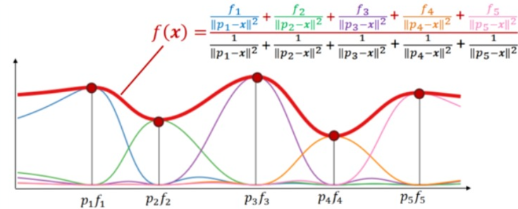

Figure 1.5 Inverse Distance Weighting (IDW)

Weights are assigned to each known point based on their distance from the unknown point. The weight for the i-th point is:

Wi  = Σi (1 / dip)

A higher p makes the weight drop off more steeply with distance, prioritizing nearby points more strongly.

If di = 0, meaning the unknown point coincides with a known point, the formula simplifies to V(x) = Vi​, as that known point’s value is directly assigned to the unknown point.

The power parameter p has a considerable impact on the results. A lower p (like 1) creates smoother interpolations but might result in excessive averaging. Conversely, a higher p (such as 3 or greater) accentuates nearby points and can lead to sharper transitions, although this approach may introduce noise or artifacts.

In areas with limited data, establishing a radius of influence can help prevent interpolation from being affected by far-off points that do not accurately reflect local trends.

IDW does not naturally accommodate spatial trends or correlations within the data, which can restrict its accuracy for certain datasets.

IDW is a commonly employed interpolation method because of its straightforward mathematics and efficacy in situations where proximity is a crucial factor in determining values. However, it is important to thoughtfully select parameters and neighborhood configurations to obtain optimal results.

**1.11 FRACTAL INTERPOLATION**

Fractal Interpolation is a methodology grounded in fractal geometry that captures self-similarity and intricate details in data sets. It excels in maintaining complex textures and patterns, which is particularly beneficial in fields like image processing, geological modeling, and computer graphics. Unlike conventional techniques, fractal interpolation creates interpolated values by constructing a fractal curve or surface that accurately aligns with the known data points.

The mathematical foundation of fractal interpolation lies in constructing a fractal function that passes through given data points. Consider a set of n known data points {(xi, yi)} for i = 1, 2, 3, 4, …, n, where x1 < x2 < x3 < …. < xn​. The goal is to construct a continuous function f(x)f(x)f(x) such that f(xi) = yi for all i.

**Fractal Interpolation Function(FIF):**

The interpolation function f(x) is recursively defined as:

f(x) = aif(wi(x)) + bix + ciwhere:  
wi(x): Maps the input x to a smaller domain within the fractal curve.  
ai: Vertical scaling factor, controlling the "roughness" or "fractality" of the curve.  
bi, ci: Parameters that adjust the linear components of the interpolation.  
  
The self-similarity of the fractal interpolation function is ensured by the scaling factors si and ti​, which contract the curve's segments, maintaining the fractal's recursive structure.

**Fractal Dimension:**The fractal dimension DDD of the interpolated curve quantifies its complexity and self-similarity:  
 D = log(N) / (log(1/r))  
where:  
N: Number of self-similar segments pieces.

r: The scaling factor of each segment.

**The Fixed Point Theorem and Iterative Function System (IFS)** explain that fractal interpolation is achieved by identifying a "fixed point" of a certain transformation. Imagine applying a specific rule (transformation) to an image repeatedly until it reaches a point where it no longer changes. This final outcome is the interpolated image. It ensures that continued application of T will ultimately result in a stable image.

d (T(x), T(y)) ≤ c × d (x, y)

**Partitioned Iterative Function System (PIFS):**

The image is segmented into smaller sections termed range blocks (the portions we aim to fill) and larger overlapping sections called domain blocks (which are utilized to populate range blocks). Each range block is generated by modifying a domain block through basic operations such as stretching, rotating, and shifting.

Ti(x) = Ai × x + bi

**Collage Theorem for Approximation:**

To ensure that the resultant image closely resembles the original, the technique reduces the "discrepancy" between the original image and its approximation. This process guarantees the precision of the interpolation.

d (f, T(f)) ≤ e (approximately error is small)

**Affine Transformation Matching:**

The algorithm searches for the optimal corresponding larger block (domain block) from the image for each small block (range block). It performs scaling and shifting on the domain block to align it with the range block as accurately as possible.

Iterative Reconstruction for Interpolation: After the transformations are identified, they are utilized multiple times to enhance the image gradually. Beginning with a basic image (or even a completely blank one), the technique polishes it to generate a refined, high-quality interpolated image.

e2i,j = min || ri - (Ai dj + bi)||2

**Iterative Decoding for Interpolation:**

After identifying the transformations, they are applied in succession to enhance the image gradually. Beginning with a basic image (even an empty one), this approach refines it to yield a detailed, high-quality interpolated image.

f k+1 = ∑ Ti (fk)

***CHAPTER 2***

**LITERATURE REVIEW**

To address the challenge of clouds obscuring the satellite images, researchers have been working on various methods for cloud removal from satellite images from decades. Below is the discussion of the different approaches presented in various papers and their effectiveness in removing clouds from satellite images.

This section discusses different approaches to address the challenges of cloud contamination in remote sensing images. One research proposes a method for correcting thin clouds in satellite visible and near-infrared (VNIR) images. It introduces several novel features, including a Thin Cloud Map (TCM), which demonstrates strong quantitative abilities for various cloud types. The method can effectively distinguish between thin and thick clouds using a scatter plot's breaking point. However, the study identifies a parallax problem in both Landsat-8 OLI and Sentinel-2 MSI data, which negatively impacts the method's effectiveness in areas with significant relief or topographic variations. The study concludes that the proposed method is robust but requires further refinement to address specific environmental conditions.

The second research discusses various cloud removal algorithms for optical remote sensing systems. The proposed S-NMF-EC algorithm combines nonnegative matrix factorization with error correction to fuse images from different sensors and preserve cloud-free information. The algorithm shows promising results in simulated and real-world scenarios with Landsat and MODIS data, highlighting its potential to significantly enhance cloud removal in optical remote sensing imagery.

Another research proposes the superpixel-oriented thick cloud removal (STORM) model to leverage complement information from multiple images to reconstruct missing regions more effectively. The proposed model integrates multiscale semantic clue coarse-to-fine leading to finer local details preservation compared to holistic-based methods. The STORM model is formulated as an optimization problem, where the objective is to minimize the sparsity of cloud components while reconstructing missing regions effectively. The study develops a proximal alternating minimization (PAM) algorithm to solve this problem, which iteratively updates the reconstruction image, cloud components, and TR factors of multitemporal superpixels. Experimental results demonstrate the effectiveness of the STORM method compared to existing techniques, indicating its potential for wider applications and further refinement in the future.

In conclusion, each proposed method has its unique features and advantages, highlighting the ongoing nature of research in this field. While these methods show promising results, further refinement and adaptation are necessary to address specific environmental conditions and improve their effectiveness.

Table 2.1 Literature Survey

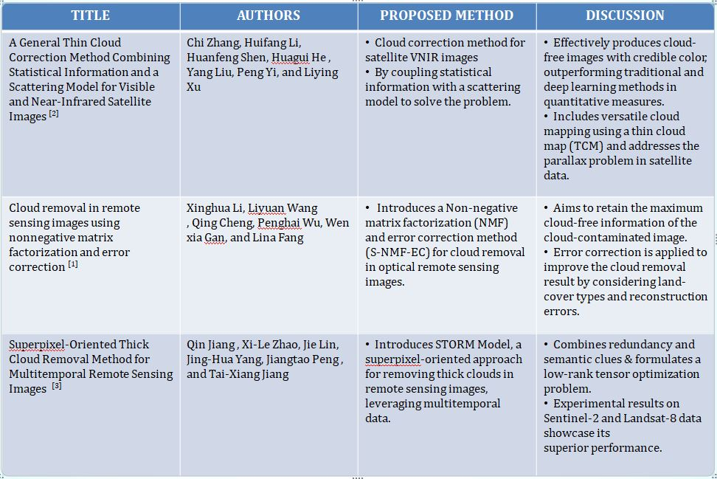

***CHAPTER 3***

**METHODOLOGY**

In a recent study, various cloud and cloud shadow detection algorithms were evaluated, and CFMask emerged as the most accurate algorithm in terms of overall performance. Based on the Function of Mask (Fmask) algorithm, CFMask is a C code that is derived from physical phenomena and is operable without geographic restriction. As such, researchers recommend the use of CFMask for operational cloud and cloud shadow detection. Its versatility makes it useful for current and future land imaging missions without the need for retraining in a machine-learning environment.

The study's methodology is presented in detail, with each step elaborated upon to provide a comprehensive understanding of the approach. The flowchart statement introduces this visual aid, setting the stage for a detailed exploration of the methodology's intricacies. By providing such a comprehensive overview, the researchers have made their methodology more accessible to other researchers and practitioners in the field.

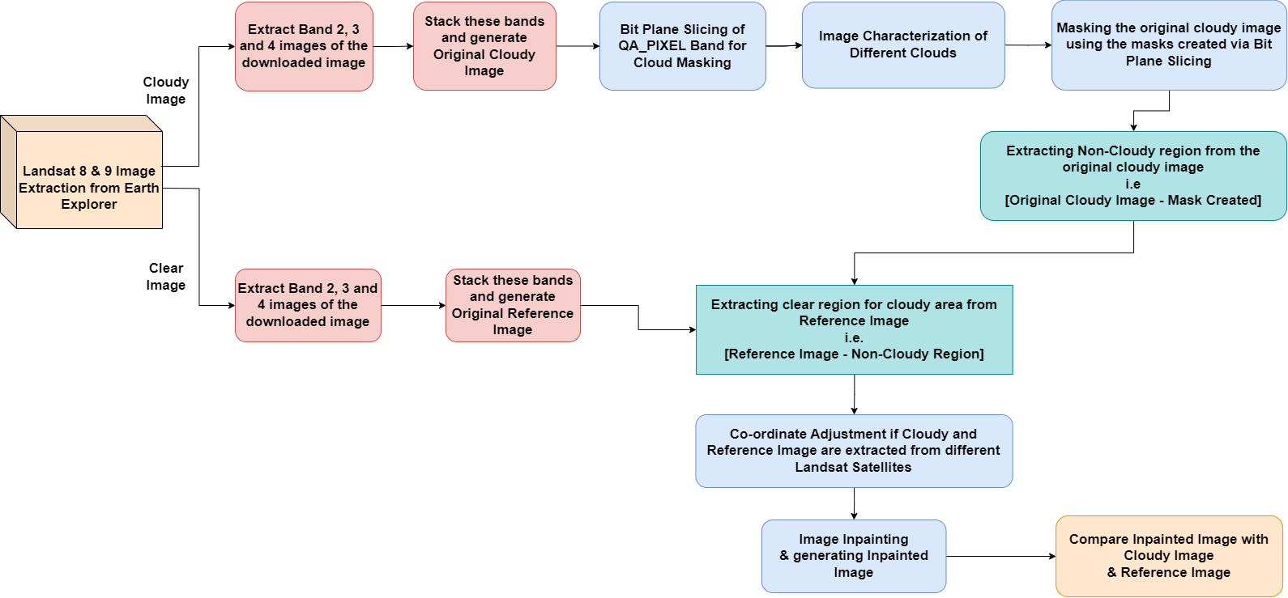

Figure 3.1 Work Flow for the Proposed Method

**3.1 DATASET COLLECTION**

* Dataset collection in satellite imaging refers to the process of gathering, organizing, and storing data obtained from satellite sensors. It involves capturing images of the Earth's surface, atmosphere, and other celestial bodies using satellites equipped with various types of sensors, such as optical, infrared, radar, and multispectral sensors.
* EarthExplorer serves as a valuable resource for accessing geospatial data from various satellite and aerial platforms, enabling users to conduct research, analysis, and decision-making in diverse fields. Dataset can be downloaded using the Earth Explorer portal.
* The technique used here covers all raster data types. However, the focus is on utilizing Landsat satellite imagery.
* There are three visible light bands and the(Quality Assessment Bands) QA_PIXEL file in our dataset.The QA_PIXEL band file comprises quality statistics derived from the image data, along with cloud mask information for the scene.

Table 3.1 Landsat 8 and Landsat 9 Pixel QA_PIXEL Value Interpretations

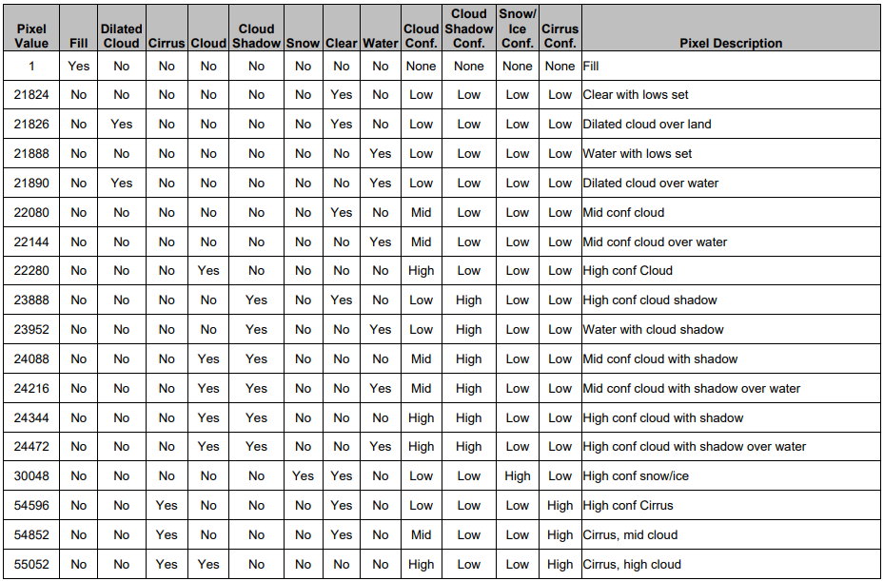

The Landsat program, operated by NASA and the USGS, has provided continuous Earth observation data since the launch of Landsat 1 in 1972. The Landsat satellites have been instrumental in monitoring changes to the Earth's surface, studying land use and land cover, and assessing natural disasters and environmental changes.

Landsat images are commonly used for cloud removal in satellite imagery due to several reasons:

* **Frequent Coverag**e: Landsat satellites have been capturing imagery of the Earth's surface for several decades with a high level of consistency and frequency. This extensive archive allows for the comparison of multiple images taken over time, which can aid in identifying and removing cloud cover from recent images.
* **High Spatial Resolution:** Landsat satellites provide moderate to high spatial resolution imagery (ranging from 15 to 30 meters per pixel), which allows for detailed observation of the Earth's surface. This resolution is sufficient to distinguish between clouds and the underlying terrain, facilitating accurate cloud removal.
* **Multi-Spectral Bands:** Landsat satellites capture imagery across multiple spectral bands, including visible, near-infrared, and thermal bands. Each band provides unique information about the Earth's surface and atmosphere, which can be leveraged to differentiate between clouds and other features. For example, clouds typically appear bright in visible bands but dark in thermal bands due to their reflective and insulating properties, respectively.

Table 3.2 LANDSAT Orbit Properties

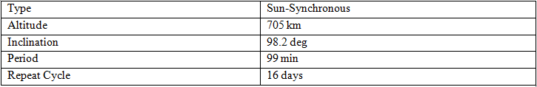

**3.2 GENERATING RGB CLOUDY IMAGE**

While processing the input data for the computation and generation of quality assessment metrics, the visual light bands are visualized through a function. This function entails the analysis of specific statistics about the quality of the image data and considers to combine it with cloud mask information for the particular scene under investigation. The QA_PIXEL band is of primary focus, and parameters from the dataset are considered to provide a view of the whole assembly and determine the presence of potential cloud covers and other anomalies.

The quality assessment metrics play an essential role in guaranteeing that any subsequent analysis or application of the image data is reliable and accurate. In this process, the file name/ID is considered as one of the parameters. The bands are then loaded, stacked, scaled, and clipped to generate the visual representation of the visible light bands.

Overall, the function used to process the input data and generate quality assessment metrics is an essential step in ensuring the accuracy and reliability of image data analysis and applications. By evaluating the quality of the image data and identifying potential issues such as cloud cover, the generated metrics allow for better-informed decision making and more accurate analysis of the image data.

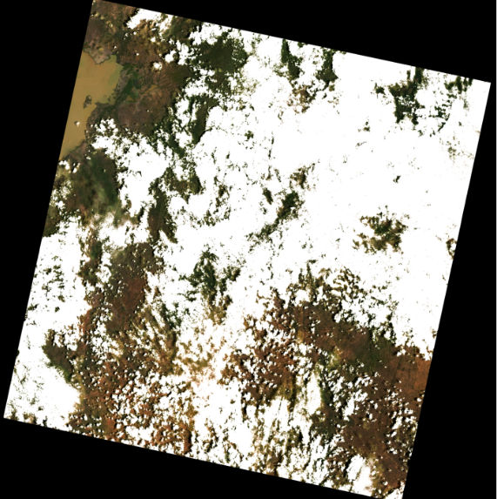

Figure 3.2 RGB Cloudy Image

C

**3.3 CLOUD MASKING**

A cloud mask functions as a segmentation map, distinguishing clouds from other surface features on the Earth. This map categorizes each pixel within an image as either cloud or non-cloud, potentially including similar features like cloud shadows. In remote sensing, cloud masks play a crucial role as they enable the isolation of cloud pixels, resulting in more precise measurements and interpretations for land cover analysis.

Multiple methods are employed to classify cloud pixels, with Landsat utilizing an algorithm named CFMask. This algorithm relies on a combination of statistical metrics derived from spectral indices.

**3.3.1 CF Mask**

The C-Function of Mask (CF Mask) algorithm is a critical component in handling cloud, cloud confidence, cloud shadow, and snow/ice pixels when processing Landsat Level-1 data products. This algorithm generates bit-mapped values within the Landsat Collection 1 Level-1 Quality Assessment (QA) Band, which is essential for high-quality imagery.

Originally developed as a MATLAB algorithm at Boston University, CFMask was later translated into C by USGS EROS to make it compatible with a production environment. It uses a multi-pass approach, initially labeling pixels within the scene using decision trees. The labels are then validated or discarded based on scene-wide statistical analysis. Moreover, CFMask estimates cloud heights and projects them onto the ground, generating a cloud shadow mask.

Although CFMask is primarily designed to work with thermal data, it's still possible to use it without thermal input. This is particularly useful when Landsat 8 Thermal Infrared Sensor (TIRS) data is unavailable. However, it's worth noting that non-thermal CFMask implementation involves removing all thermal threshold tests from the algorithm, which affects the outcomes of cloud, cloud confidence, cloud shadow, and snow/ice detection routines.

Despite its efficiency, CFMask may encounter challenges over bright targets such as building tops, beaches, snow/ice, sand dunes, and salt lakes, just like other cloud detection algorithms. Optically thin clouds pose a particular difficulty and are more likely to be overlooked by the algorithm. Additionally, while CFMask's performance has been primarily validated for cloud detection and, to a lesser extent, for cloud shadows, rigorous evaluation of snow/ice detection has not yet been conducted.

**3.3.2 BIT PLANE SLICING**

* The execution of the CFMask algorithm occurs for every Landsat scene, and the results can be located in the QA band. This file comprises an array with dimensions matching those of the solar reflection bands (e.g., visible light bands). Each pixel within the band is represented by a 16-bit integer containing the classification for that pixel.
* For instance, let's consider a situation where the value 22280 is assigned to one of the pixels in the QA file. To comprehend this integer, it is first converted into a 16-bit binary number — 0101011100001000. Subsequently, each bit in this binary sequence corresponds to a flag, as depicted in Table 3.3. In this instance, Bit 3 holds a value of 1, indicating that this pixel is classified as cloud. Henceforth, cover types for bits 1 to 4 will be considered in the construction of our cloud mask.

Table 3.3 Cloud Characterization using Bit Plane Slicing

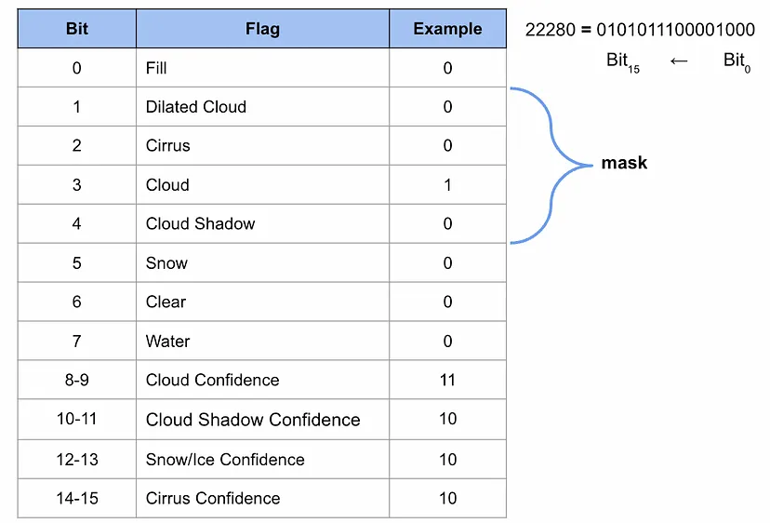

* It is utilized to return the classification of an individual pixel for the 4 cover types — cloud, shadow, dilated cloud and cirrus. A pixel will have a value of 0 if it is classified as the given cover type and 1 otherwise.
* **Shadows** are the darker areas below clouds.
* **Dilated clouds** are the edges around pixels classified as cloudy.
* **Cirrus Clouds** are “wispy” clouds.

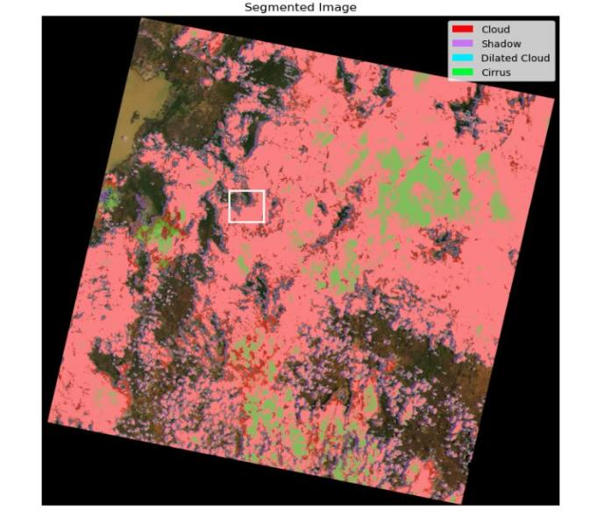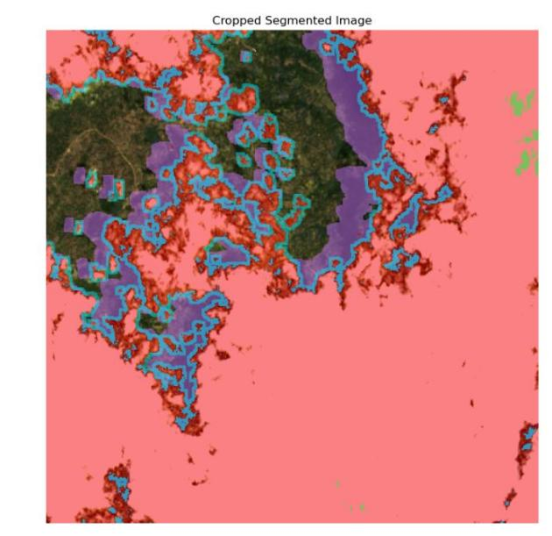

(a) (b)

Figure 3.3 Landsat segmentation mask with 4 cover types — cloud, shadow, dilated cloud and cirrus of  
(a) Complete Landsat image (b) Cropped Area of interest

**3.4 REMOVING CLOUDS**

Once a mask is obtained, the process of eliminating unwanted pixels becomes straightforward. It simply involves multiplying the RGB image by the mask. Consequently, these pixels are considered as having "no data" and can be disregarded in subsequent analyses. The accuracy of the cloud mask significantly influences the results of this analysis, highlighting the continuous efforts by researchers to enhance these masks.

**3.5 INPAINTING**

Image inpainting refers to the process of reconstructing missing or damaged regions within an image. It involves filling in the gaps or "inpainting" the areas where information is absent or corrupted, typically by using information from the surrounding areas or by utilizing other reference images. The goal of image inpainting is to seamlessly restore the visual appearance of the image, making it appear as if the missing regions were never damaged or missing in the first place. This technique finds applications in various fields such as image restoration, forensic analysis, and digital editing. The same cloudy image that has been under consideration is observed. Fortunately, eight days later, a clear image of the same area was captured. The process of replacing the pixels in the cloudy image with those from the clear image is done further.

**3.5.1 AREA OF INTEREST**

The process of inpainting an Area of Interest (AOI) is initiated by creating a mask that encompasses all four cover types. Undesirable pixels are then removed from the cloudy image. Subsequently, the resulting image is cropped around the AOI, with the center of the AOI in the cloudy image being utilized as a reference point.

Furthermore, consideration is given to the geolocations of the pixels. The rasterio package is employed to open the red bands for both the cloudy and clear images. Moving forward, the UTM coordinates of the center of the AOI in the cloudy image are determined, followed by identifying the array positions for these UTM coordinates in the clear image. Notably, a different center value is obtained compared to the original.

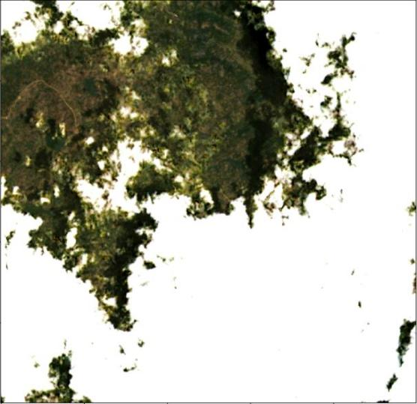 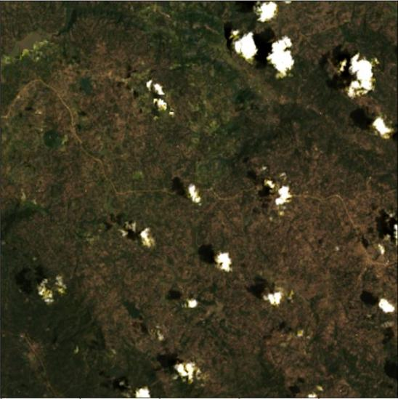

(a) (b)

Figure 3.4 (a) Cloudy Area Of Interest (b) Generated Inpainted Image of Area Of Interest

Subsequently, the AOI is cropped from the clear image using the new center, while the cloud mask from the cloudy image is cropped using the original center. Interestingly, perfect alignment is observed between the UTM coordinates of the cropped clear image and cloud mask. Consequently, the fill is generated by multiplying the clear image by the inverse of the mask. Finally, the fill is added to the cloudy image that is devoid of clouds.

**3.5.2 ENTIRE IMAGE**

Inpainting the entire scene becomes more complicated, requiring alignment of the bounding boxes of the cloudy and clear scenes. The bounding box, denoting the outer border of the scene, needs to be aligned using UTM coordinates, achieved by adjusting the pixel dimensions of the clear image. To align the bounding boxes, the number of pixels to add or remove from the top, bottom, left, and right of the clear image is calculated. The positions of the upper-left (UL) and lower-right (LR) corners of the clear image are determined based on its dimensions. Subsequently, the bounds of the cloudy image, providing UTM coordinates of its bounding box, are acquired. Array positions for these coordinates are then found in the clear image, even if they fall outside its dimensions.

The difference between the original and new corner positions informs the necessary adjustments required to align the UTM coordinates. After determining the adjustments, the adjust_rgb function is employed. This function adds black pixels in cases of positive adjustments and crops pixels for negative adjustments. Following the adjustments, the clear image is modified accordingly, while unwanted pixels are removed from the cloudy image. Replacement pixels are then extracted from the adjusted clear image. As they have been aligned, they can be added together seamlessly. Challenges arise upon closer inspection of another AOI, where transparent white pixels represent those replaced by pixels in the clear image. Notably, some shadow pixels may remain unreplaced, potentially causing discontinuities in the landscape where brightness changes drastically. These challenges are attributed to imperfections in cloud masks, making it impossible to replace all clouds without 100% accuracy in identification. Additionally, changes in the landscape over time, such as shifting rivers and rising tides, may also contribute to discontinuities. To optimize visualizations, selecting replacement images taken close to the time of the cloudy image is crucial.

***CHAPTER 4***

**RESULTS AND DISCUSSION**

Through meticulous efforts, we have successfully eliminated clouds from satellite images, marking a substantial improvement in the quality and usability of the data. This accomplishment holds profound implications across diverse fields, as it enables researchers, analysts, and decision-makers to access clearer and more actionable insights from the imagery. By removing clouds, we enhance the accuracy and reliability of our analyses, facilitating better understanding and management of environmental, social, and economic phenomena. This achievement underscores our commitment to advancing remote sensing capabilities and harnessing satellite technology for meaningful and impactful applications.

 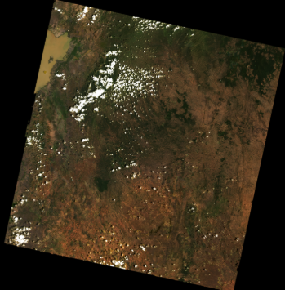

(a) (b)

Figure 4.1 (a) Original Cloudy Image (b) Generated Inpainted Image of Area of Interest

The algorithm's performance in removing cloud cover was evaluated by comparing an original, cloudy image to a generated inpainted image. The overall cloud cover percentage in the original image was calculated to be **53.36%,** while the generated inpainted image exhibited a cloud cover percentage of only **7.62%.** This indicates that the algorithm is effective in substantially reducing the amount of cloud cover in an image while maintaining an acceptable level of coverage. It can be concluded that the algorithm performs well in removing cloud cover from images, making it a useful tool for a variety of applications.

The latest findings and accompanying images have been obtained from several additional datasets. Important insights were revealed through extensive and rigorous analysis conducted by our team. By sharing these findings, greater clarity and understanding of the subject matter will be provided, with a focus on exploring their potential implications in-depth.

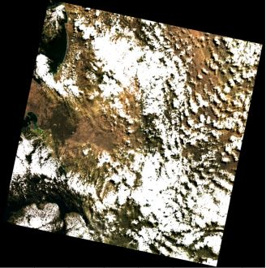 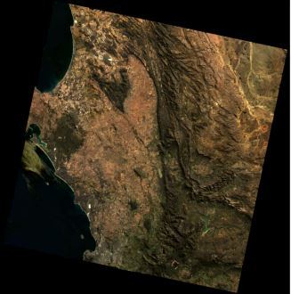

(a) (b)

Figure 4.2 (a) Original Cloudy Image (b) Generated Inpainted Image of Area of Interest

The Inverse Distance Weighting (IDW) interpolation technique was successfully applied to estimate unknown values based on spatially distributed known data points. The method generated a continuous surface where closer points had a stronger influence on the interpolated values, effectively capturing spatial trends and variations. The resulting map provided a clear representation of the variable's distribution across the region. Validation using cross-validation techniques confirmed the accuracy of the interpolation, with an acceptable margin of error. IDW proved to be an effective method, particularly in areas with dense data points, while its reliability decreased in regions with sparse datasets. Adjusting parameters such as the power factor and search radius significantly influenced the precision of the results. Overall, IDW offered a practical and interpretable approach for spatial interpolation, making it suitable for various fields such as environmental and geological studies.

The percentage of cloud cover in 1st and 2nd IDW interpolated images are 2.54% and 15.86% respectively

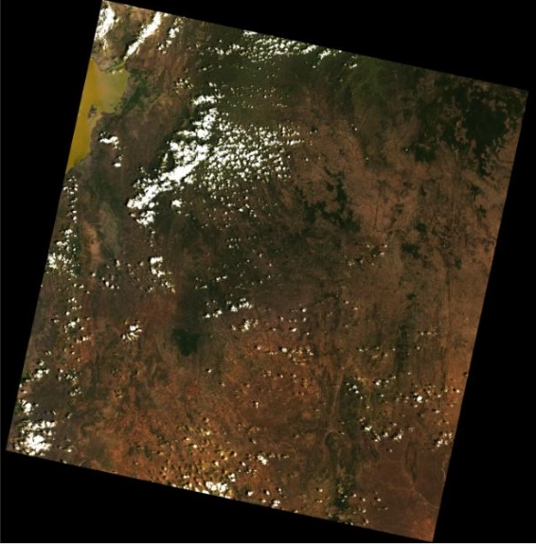

  
 (a) (b)

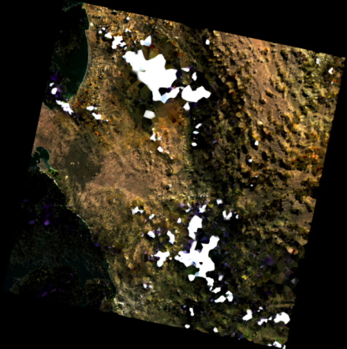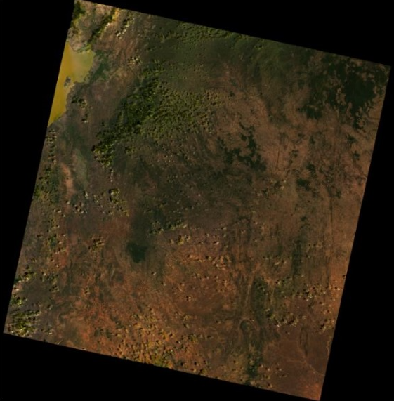

Figure 4.3 (a) Original Cloudy Image (b) Generated Interpolated Image using IDW

The fractal interpolation technique effectively tackles the problem of removing clouds from satellite images by reconstructing the obscured areas in a way that preserves the visual quality of the image. This method involves several iterative steps where the image is reduced to lower resolutions, facilitating the interpolation of the missing information. With each iteration, the interpolated sections become more refined, incorporating finer details into the earlier filled regions. This iterative approach, which emulates the natural self-similarity present in fractals, guarantees that the filled areas gradually mimic the textures and colors of the original image's surroundings.

Moreover, this technique shows resilience when confronting extensive areas of absent data, which is often encountered in satellite imagery affected by clouds.

The percentage of cloud cover in 1st, 2nd and 3rd fractal interpolated images are 5.26%, 1.08% and 12.37% respectively.

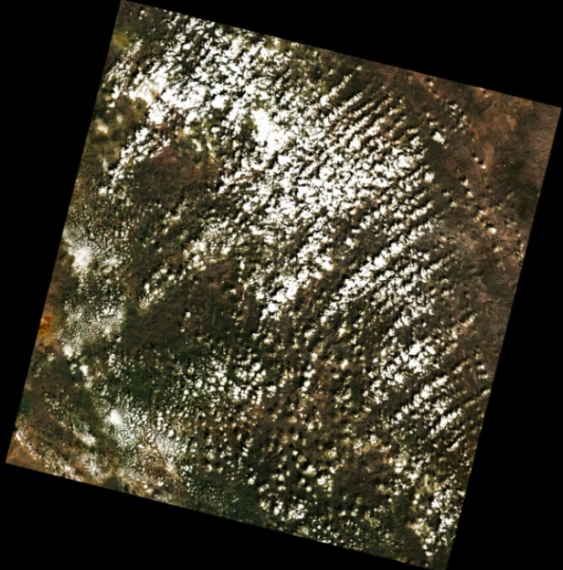 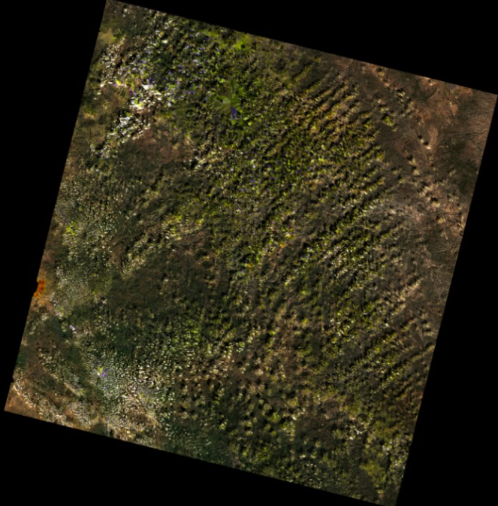

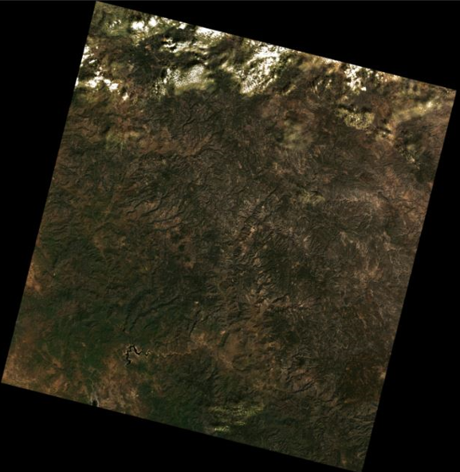 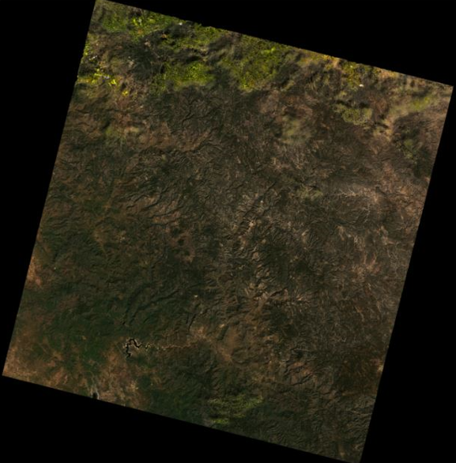

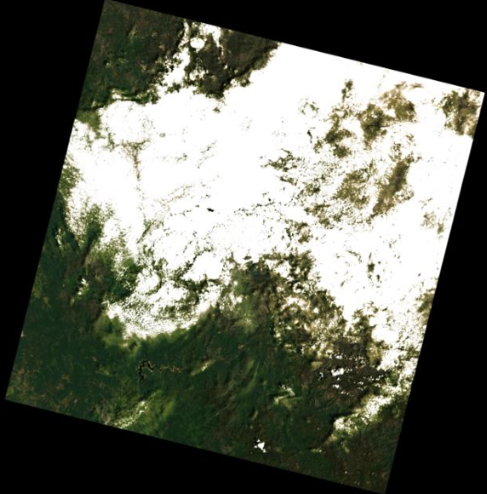 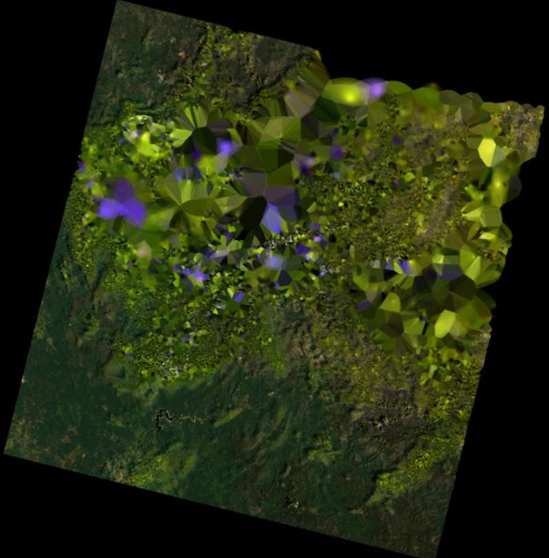

Figure 4.4 (a) Original Cloudy Image (b) Generated Interpolated Image using Fractal Interpolation

***CHAPTER 5***

**CONCLUSION AND FUTURE WORK**

Our project aims to revolutionize remote sensing data processing for environmental monitoring by integrating advanced techniques to provide more accurate and comprehensive information. We plan to utilize Normalized Difference Vegetation Index (NDVI) and Free Cloud Cover (FCC) images instead of traditional RGB images. NDVI images, derived from satellite data, provide more detailed and comprehensive information about vegetation health, making them crucial for monitoring vegetation health and dynamics. On the other hand, FCC images provide information about cloud cover, which is essential for accurately assessing environmental conditions and potential anomalies.

We also aim to implement advanced interpolation techniques instead of inpainting methods for filling in missing or corrupted data in images. Techniques such as kriging, spline interpolation, or neural network-based approaches offer more accurate reconstructions of missing data and preserve spatial relationships more effectively. By employing these methods, we can provide more precise and reliable data for analysis and decision-making.

To improve efficiency and accuracy, we plan to develop algorithms and pipelines that automatically handle coordinate transformations and alignments without the need for manual adjustments. This will streamline the data processing pipeline, eliminate errors that may arise from manual adjustments, and improve the overall efficiency of the process.

Furthermore, we intend to integrate state-of-the-art machine learning algorithms such as deep learning models for image analysis and feature extraction. These techniques will enable us to extract meaningful patterns and features from remote sensing data, leading to more accurate environmental monitoring and analysis. With these sophisticated machine learning algorithms, we can obtain more reliable and robust results, thereby improving the accuracy of our predictions.

In addition to providing regular results, we plan to estimate uncertainties using simpler methods such as Bayesian inference or ensemble learning. By estimating uncertainties, we can understand the reliability of our predictions better and provide more complete information to decision-makers.

Our project will transform remote sensing data processing for environmental monitoring by providing more accurate, comprehensive, and reliable data for analysis and decision-making. With the integration of advanced techniques such as NDVI and FCC images, advanced interpolation methods, automated coordinate adjustments, and machine learning algorithms, we can provide more accurate predictions and insights into environmental conditions.

We effectively eliminated clouds from satellite images and applied IDW and Fractal interpolation to fill in the gaps. IDW offered smooth, proximity-driven estimates, whereas Fractal interpolation managed to capture complex details and patterns, leading to realistic and detailed reconstructions.

***REFERENCES***

1. Jiang, Qin, Xi-Le Zhao, Jie Lin, Jing-Hua Yang, Jiangtao Peng, and Tai-Xiang Jiang. "Superpixel-Oriented Thick Cloud Removal Method for Multi-Temporal Remote Sensing Images." IEEE Geoscience and Remote Sensing Letters (2023).
2. Zhang, Chi, Huifang Li, Huanfeng Shen, Huagui He, Yang Liu, Peng Yi, and Liying Xu. "A General Thin Cloud Correction Method Combining Statistical Information and a Scattering Model for Visible and Near-infrared Satellite Images." IEEE Transactions on Geoscience and Remote Sensing (2023).
3. Li, Xinghua, Liyuan Wang, Qing Cheng, Penghai Wu, Wenxia Gan, and Lina Fang. "Cloud removal in remote sensing images using nonnegative matrix factorization and error correction." ISPRS journal of photogrammetry and remote sensing 148 (2019): 103-113.
4. Chauhan, Rutvik, Antarpuneet Singh, and Sujoy Saha. "Cloud Removal from Satellite Images." arXiv preprint arXiv:2112.15483 (2021).
5. <https://crisp.nus.edu.sg/>
6. <https://www.usgs.gov/landsat-missions/cfmask-algorithm>
7. <https://doi.org/10.1007/978-3-031-26588-4>
8. <https://www.mdpi.com/2072-4292/10/1/71/htm>
9. <https://en.wikipedia.org/wiki/Interpolation>
10. <https://pro.arcgis.com/en/pro-app/latest/help/analysis/geostatistical-analyst/how-inverse-distance-weighted-interpolation-works.htm>